**Practical No. 12**

1. **Working with AsyncTask**

**Designing UI:**

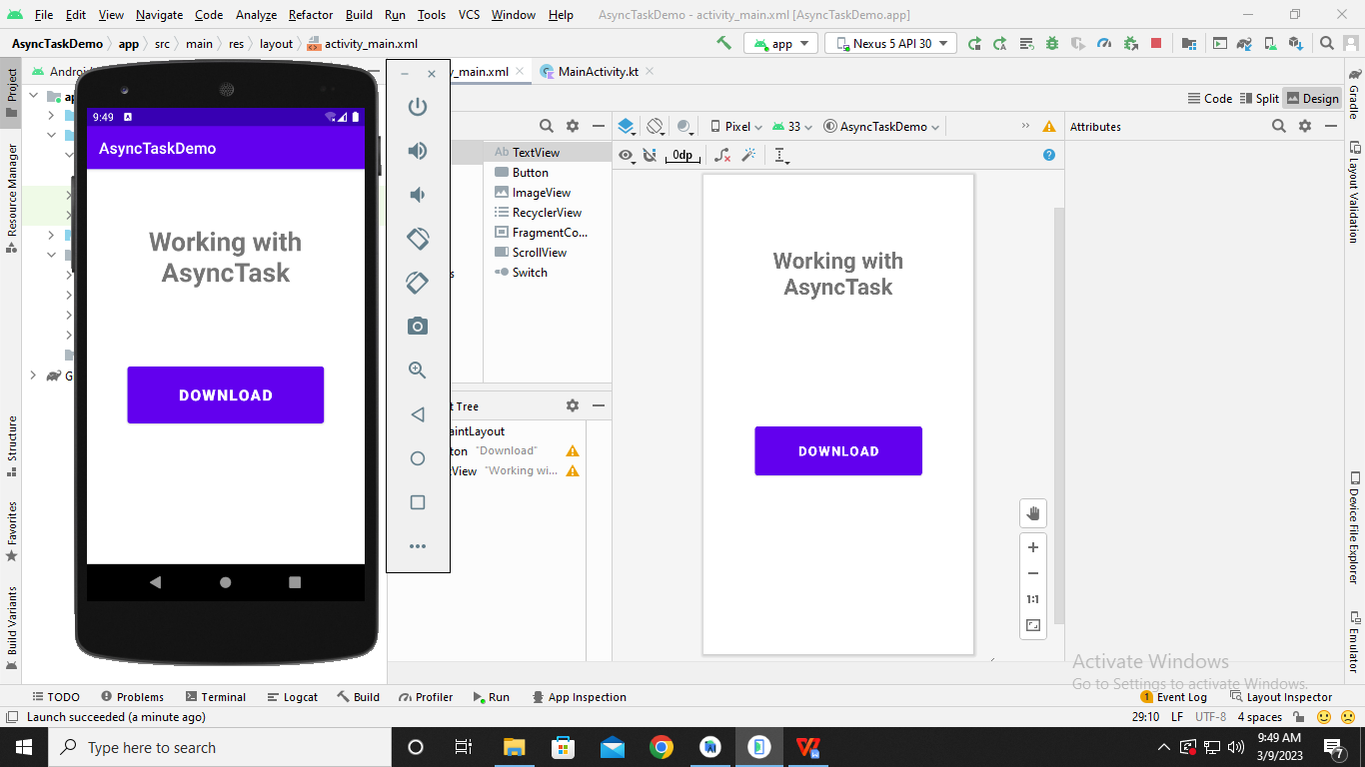

**Code:**

**package** com.example.asynctaskdemo  
  
**import** android.app.ProgressDialog  
**import** android.os.AsyncTask  
**import** androidx.appcompat.app.AppCompatActivity  
**import** android.os.Bundle  
**import** android.view.View  
**import** android.widget.Button  
**import** android.widget.Toast  
  
**class** MainActivity : AppCompatActivity() {  
**var pd**: ProgressDialog? = **null  
 override fun** onCreate(savedInstanceState: Bundle?) {  
**super**.onCreate(savedInstanceState)  
 setContentView(R.layout.*activity_main*)  
**val** btn = findViewById<View>(R.id.*button*) **as** Button  
 btn.setOnClickListener **{  
val** asyncTaskExample = AsynkTaskExample()  
 asyncTaskExample.execute()  
**}**}  
  
**inner class** AsynkTaskExample : AsyncTask<String?, String?, String?>() {  
**public override fun** onPreExecute() {  
**super**.onPreExecute()  
**pd** = ProgressDialog(**this**@MainActivity)  
**pd**?.setMessage(**"Please wait.... file download in progress...."**)  
**pd**?.show()  
 }  
**override fun** doInBackground(**vararg** params: String?): String? {  
**try** {  
 Thread.sleep(15000)  
 } **catch** (e: InterruptedException) {  
 e.printStackTrace()  
 }  
**return null**}  
**public override fun** onPostExecute(result: String?) {  
**pd**!!.hide()  
 Toast.makeText(*applicationContext*, **"File download complete..."**, Toast.*LENGTH_LONG*)  
 .show()  
 }  
 }  
}

**Output:**

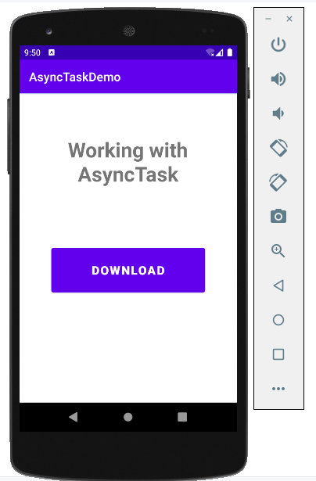

**After Clicking ‘DOWNLOAD’**

